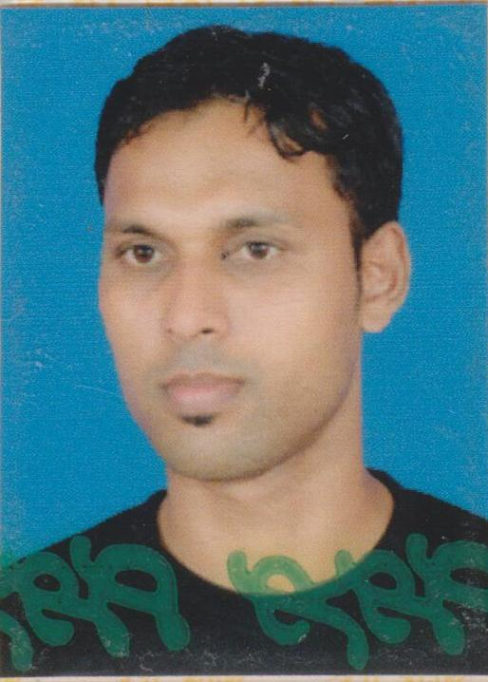

Mohamed Asmi Farook

APPLICATION FOR THE POST OF

Career

Expertise

Achievements

Credentials

No. 180/B/47, Grandpass Road,
Colombo – 14,
Sri Lanka.

Mobile : 0777 851 049/ 0775 274 677
0775 544 747
E-mail : asmifarook47@gmail.com

To obtain a challengeable role that will allow enhancing upon gained experience and self-confidence with accumulate educational and trade-training knowledge.
::
OBJECTIVE

::
STRENGTHS

- Extensive industry/ market knowledge.
- Strategic planning and controls.
- Excellent analytical and interpersonal skills.
- Strong team player.
- Innovative in approach.
- Self- starter performs best under pressure.
- Good time management skills.

::
CAREER HISTORY (In reverse chronological order)

- Present Employment : Recruiting Manager
Ibrahim Enterprises (Pvt) Ltd.
(Same position in Dewan Consultants – LL No. 2898, sister
Company of Ibrahim Group)
# 52, First Floor, Hospital Steert
Colombo -01 (LL No. 833)

Since Feb 2013 to date

- Professional Experience
 | Name of the Company | Designation | Remarks / Period
3 | Arabian Gulf Enterprises  72/26, Sri Sangarajaha Mw.,  Colombo 10  LL No. 969 | Senior Recruiting Executive  - Coordinating with top management of all the job orders  -Supervising all the recruiting staffs according to the  interview lineup  -Conducting the direct interviews with foreign principles  according to clients requirements  - Having good knowledge of Man hunting / Evaluating  candidates / Office Filing systems / Processing  - Moving with Embassy documentations such as Kuwait  / KSA and handling all the documentation of SLBFE for  Job orders approval  - Email correspondence / Communications with overseas companies | From Sep 2007 to Sep 2012  (05 Years)
2 | Al-Karim Overseas Consultants (Pvt) Ltd  #94 1st Floor,  Chatham Street,  Colombo  LL No. 1933 | Recruiting Assistant  -Handling the Job Orders  -Formalities of recruitments  -Client’s requirements’ to be updated  -Email correspondence / Communications  -Focusing on selections by the clients  -Candidates’ Mobilization as per agreements | From June 2005 to  August 2007  (02 years)
1 | Hotel Holiday Inn  # 30, Sri Mohamed Macan Markar Mw, Colombo-03 | Room Boy / In-charge of Mini Bar &  Floor Supervisor  -Responsible for smooth operation of the floor assigned  -Responsible for the performance of room attendance  -Organises and facilitates the room making process  -Ensures that the entire operation is performed as per the laid down standards  -follow up daily routines  -Caring visitors’ attitudes  -Manage guest requests, including VIP amenities and communicating them to the relevant team members  -Carry out lost and found procedures | From May 2001 to May 2004  (03 years )

PROFESSIONAL QUALIF ICATION
ICATIONS
::

- Completed one year course in Housekeeping Effectives as a Room Boy at Hotel
Holiday Inn Colombo (4++ Star )
- Followed Certificate of proficiency craftsman in the trade of Room Boy at National Apprentice of Industrial Training Authority
- Was a teacher for Sunday Islamic School (Y.M.M.A Mutwal Ahadiya School) since
1998 to date

ACADEMIC QUALIF ICATION
ICATIONS
::

- G.C.E. Ordinary Level Examination - 1998

COMPUTER l LITERACY

::

- General windows based Application Software
- Ms Office XP version and above (Windows O/S, Word, Excel, PowerPoint, Access)
- General Trouble shootings & Hardware Configuration & Installation on a PC
- Internet & Email

EXTRA CURRICULAR ACTIVITIES

::

- A member of M.Y Crick Club 1998 – 2000
- School Tournament of First XI – Football - 1997 / 1998
PERSONAL DETAILS
::

Name in full : Mohamed Farook Mohamed Asmi

Date of Birth : 1982 June 11th

Age : 33 Years
Marital Status : Married.
Sex : Male
NIC # : 821630509V
Passport # : N1204730
School Attended : Co/Mo/ Hamza Muslim Maha Vidyalaya,
Nationality : Sri Lankan.
Religion : Islam (Muslim)
LANGUAGES
::

- Tamil : Written / verbal - Very Good Understanding
- Sinhala : Written / verbal - - do –
- English : Written / verbal - Satisfactory Status for best affections

(1)  NON – RELATED REFEREES  ::  Mr. A C M Sabry  (Assistant Superintend of Customs)  Sri Lanka Customs  Times Building, Fort  Colombo - 01  Sri Lanka,  Mob – (+94) 77 3549896, | (2)  Mr. Y Shariffo Deen (Operation Manager)  Ibrahim Group,  # 52, 01st Floor Hospital Street,  Colombo-01, Sri Lanka  Tel : (+94) 112 392011 / 12  Mob – (+94) 772 293055  Email- yqeensariffodeen@yahoo.com
I do hereby declare that above details are true and correct as the best of my knowledge.

Date Signature

